RUMC Quickstart Guide

9 am Traditional Worship

Nursery G-7

Wiggle Worship during sermon G-1

10 am Sunday School

For all ages

Nursery G-7

See back for details and locations

11 am Modern Worship

Nursery G-7

Wiggle Worship G-1
Entire service or
during sermon

Accessibility Statement

Safe Sanctuaries Statement - Kiosk Check-in

For more information, visit our Connection Corner in the front lobby

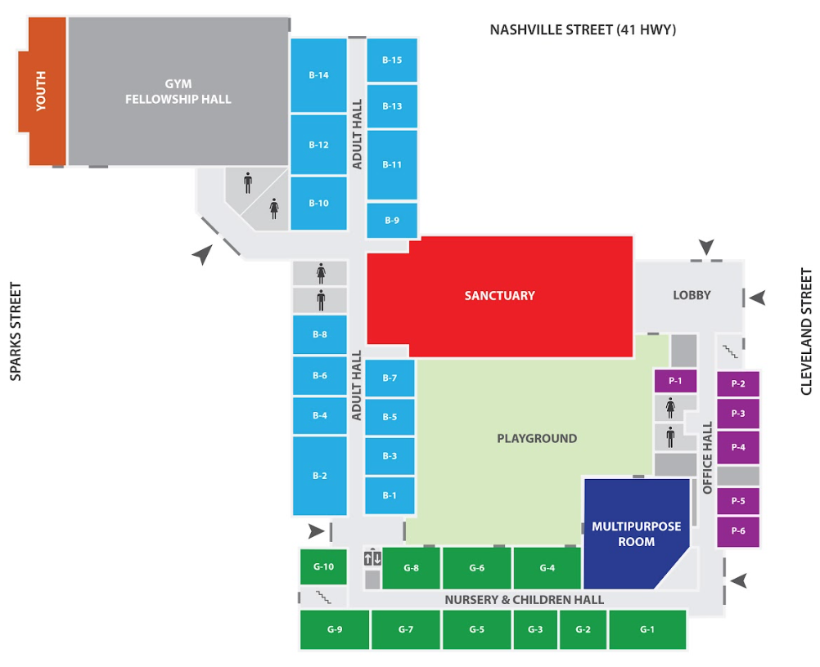

Adult Sunday School Classes
Bible For Today B - 10
FOB B - 4
Workers For Christ B - 13
Seekers B - 1
Bridge B - 2
New Kids B - 3

Youth Sunday School B - 6

Children’s Sunday School G - 2

Wednesday Evening Children and Youth Programs 6-7:30 pm
Children meet in Wiggle Room G-1
Youth meet in Gym

Visit our Website - QR Code

